Aquarium

Subject:  Related Subjects: | Grade Level(s): 1,2,3,4,5,6,7  Length of Lesson: | Type: Inquiry / Design / Project  Keywords: Align, seal, score, oxygenate

Lesson Overview
Use this section to describe at a high level what the lesson is. Should be no more than 3-4 lines.

Lesson Focus
What is the central question or phenomenon being investigated? What problem are they trying to solve?

Lesson Objective(s) | • Students will design and build an aquarium or a terrarium  • Students will select the fish or plants to inhabit  • Students will use the metric system to measure pieces

Lesson Timing

5 minutes | Introduce the Lesson
30 minutes | ...

Materials | - –Plexiglas  - –Plywood  - –Hot Glue  - –White glue  - –Hot glue gun  - –Hammer  - –Nails  - –Scroll saw  - –Drill  - –Drill Bits  - –Ruler  - –Petroleum jelly  - –Paint brush
Instructor Prep | - Step 1
Related Resources | - List related lessons/ppts etc available from USC or outside, trusted orgs

Lesson Plan

Introduction
An aquarium is a tank, bowl, or other water-filled enclosure in which living fish or other aquatic animals and plants are kept. A terrarium is a small enclosure or closed container in which living plants and sometimes small land animals, such as turtles and lizards, are kept and observed.

Procedure
- –Divide the Plexiglas by drawing 15cm x 15cm squares
- –Score (repeatedly trace with sharp object) along the lines (Don’t remove covering)
- –Using the scroll saw, carefully cut along the lines. Each aquarium uses 2 pieces of Plexiglas
- –Cut 1piece of plywood 15cm x 15cm. This is the base
- –Cut 2 pieces of plywood 15cm x 14.5cm. These are the sides
- –Hot glue the sides opposite each other on the base, flush with the sides of the base (creating a square U)

- –When dry, turn “square U” upside down. Carefully, hammer 5 nails through base into each side

- –Seal inside edge between base and sides by applying white glue.
- –Using paintbrush, cover inside of sides and base with thin even cover of white glue (be careful not to get splinters).
- –Allow glue to dry for one day.
- –Apply thin coat of petroleum jelly to sides and base.
- –Drill three hole on opposite sides of each Plexiglas sheet

- –Hot glue on sheet on side of “square U”.

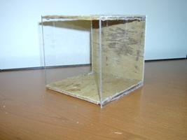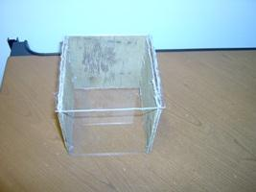
- –Carefully hammer nails through Plexiglas into wood
- –Repeat for other side
- – Seal inside edges between Plexiglas and wood sides by applying white glue.

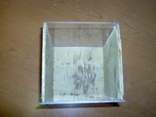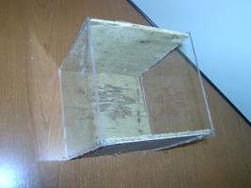

Wrap-up
Using a motor and propeller, students create an oxygen pump to re- oxygenate water.

Lesson Background for Teachers

Suggested Real-World STEM Connections
- List possible related Role Models in STEM (with details and links to more reading). Give suggestions for examples of scientists/engineers who are from underrepresented groups in STEM in related careers.
- List related real-world engineering problems and examples

Lesson Variations and Options
Include descriptions of alternative methods or ways to present things.

Explanation
Describe the background concepts and explanations behind the lesson. This can be more in depth than a teacher/instructor would actually share with students.

Key Concepts and Vocabulary
- Word 1: Grade Appropriate Definition
- Word 2: Grade Appropriate Definition

Safety Notes
- Safety instruction

